**Ilastik processing steps:**

1. Open Ilastik version 1.3.3 and select the “ColonyMorphologyPixelClassifier.ilp” project file.
2. Select tab 3 “Training” and click on “Live Update” button. Wait for training to finish.

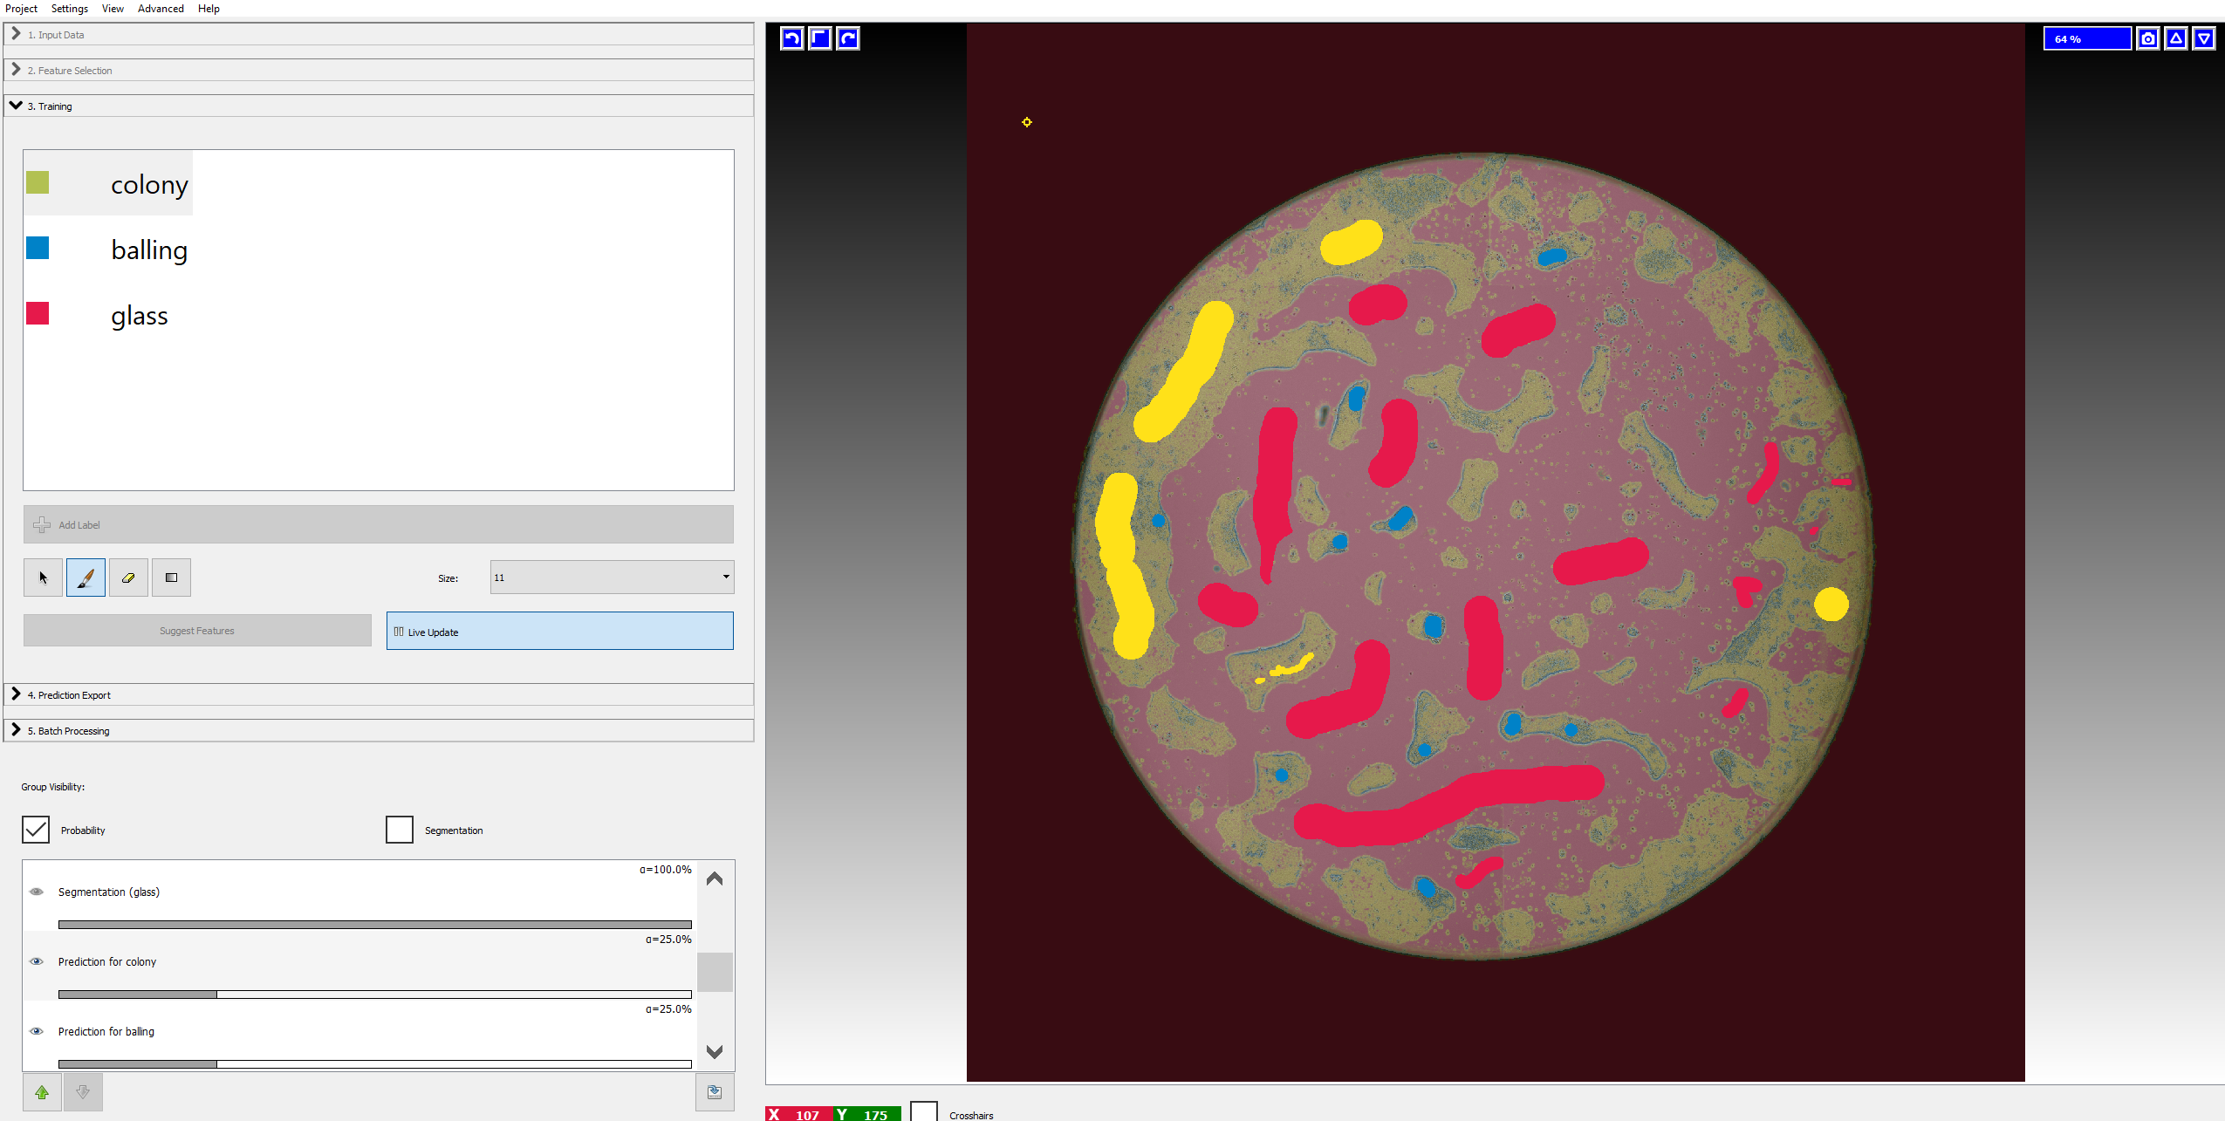

1. Select tab 5 “Batch Processing” and clikc on “Select Raw Data Files”

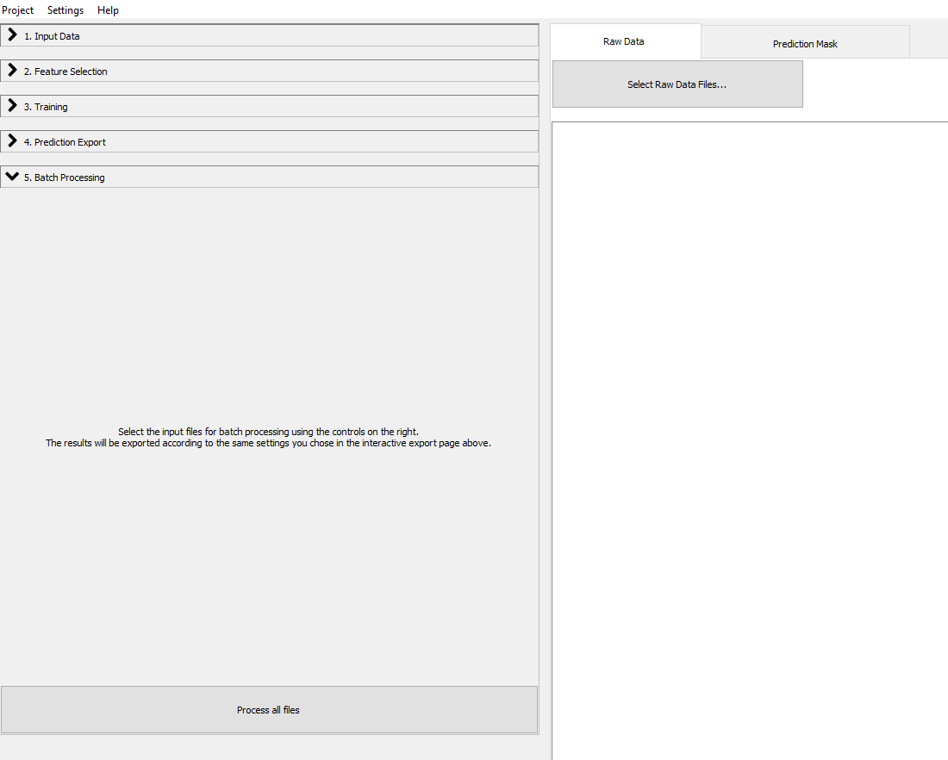

1. Select the example Celigo well scan tiled images with the suffix “_resized.tiff” that are in the “InputImages” folder.
2. Click on the “Process all files” button to generate the pixel probability maps that are inputs for the CellProfiler pipeline. This processing step will take a few minutes to execute.

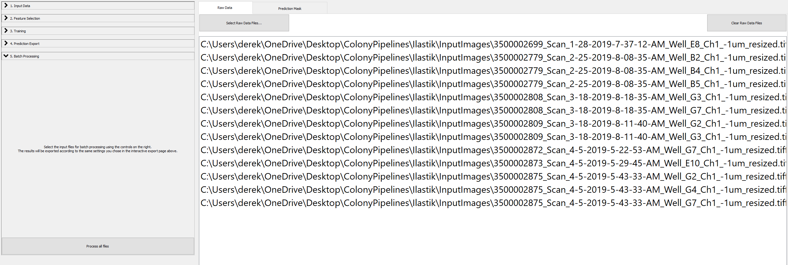

**CellProfiler processing steps:**

1. Open CellProfiler version 4.0.7 and select import pipeline from file option. Load 96_well_colony_pipeline.cppipe that is located in the CellProfiler folder.

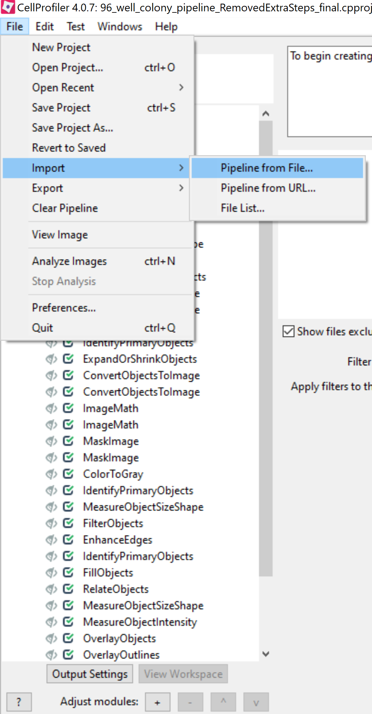

1. Set output folder in the Output setting tab. The output files from the pipeline will be stored here. …\ColonyPipelines\CellProfiler\InputImages\Output

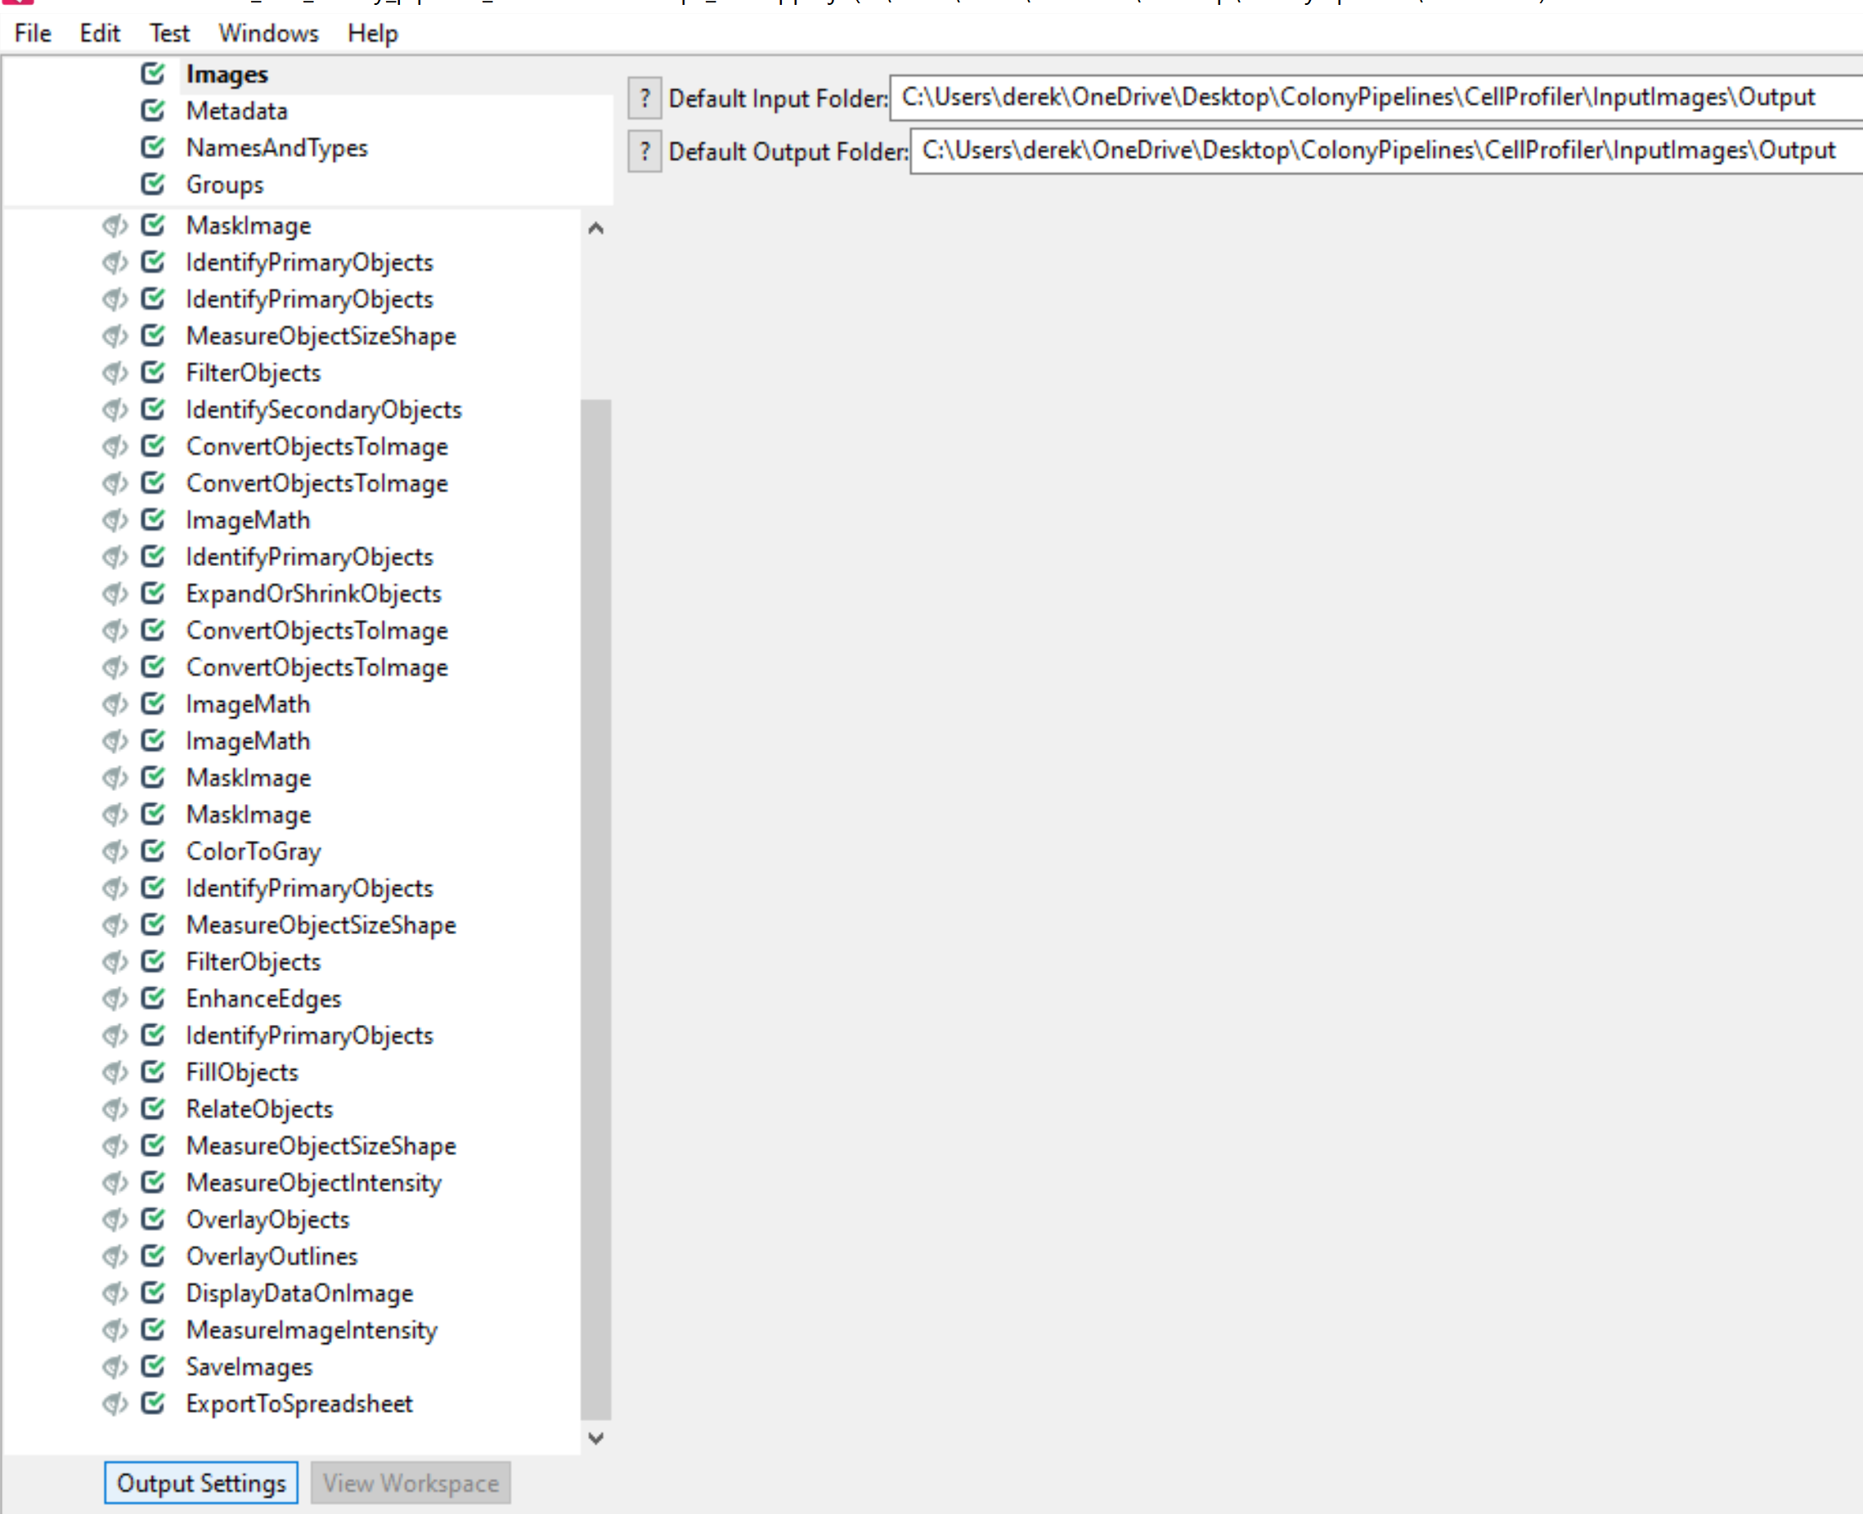

1. Drag “InputImages” folder into the white box in the GUI labeled “Drop files and folders here”.

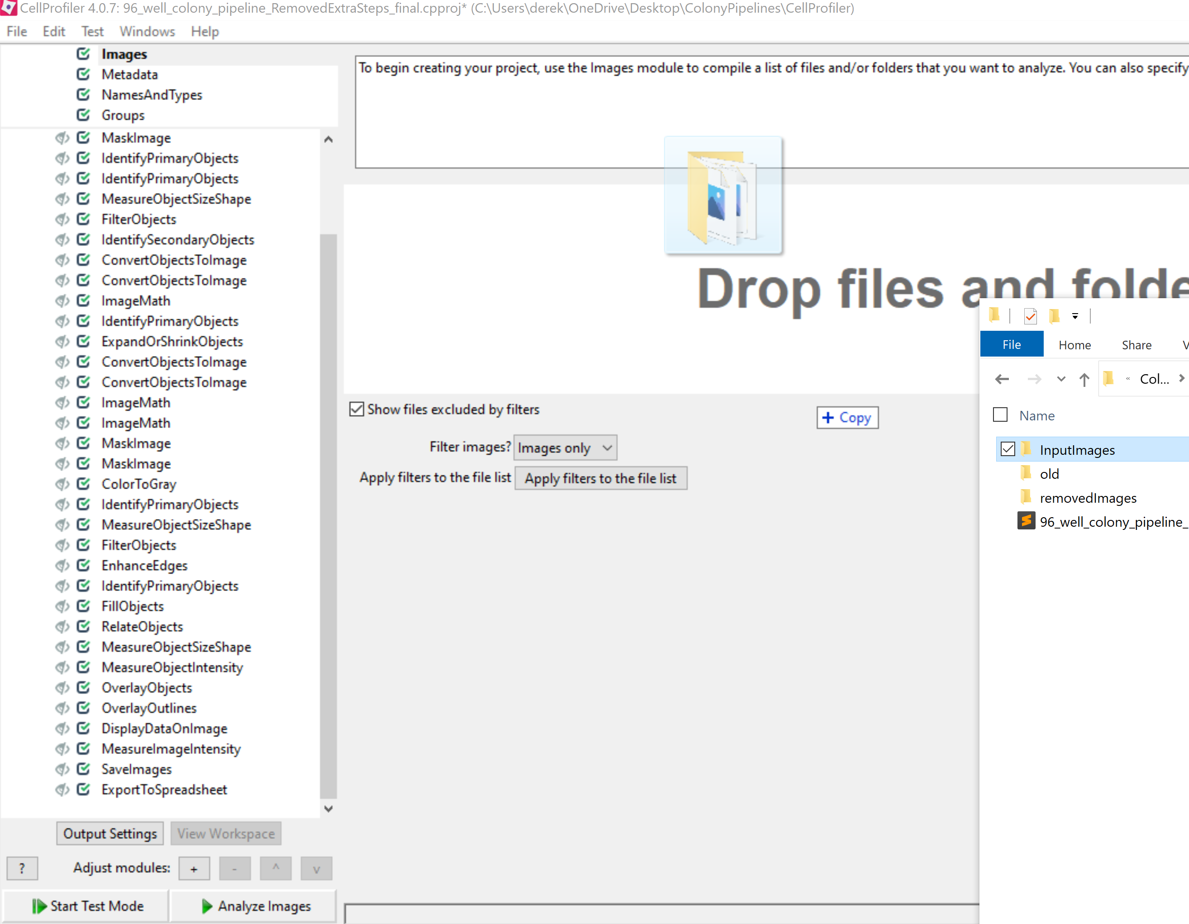

1. Proceed to Metadata tab. The regex pattern has been set to the file naming convention of our Celigo image cytometer. This regex will need to be changed for other naming conventions.

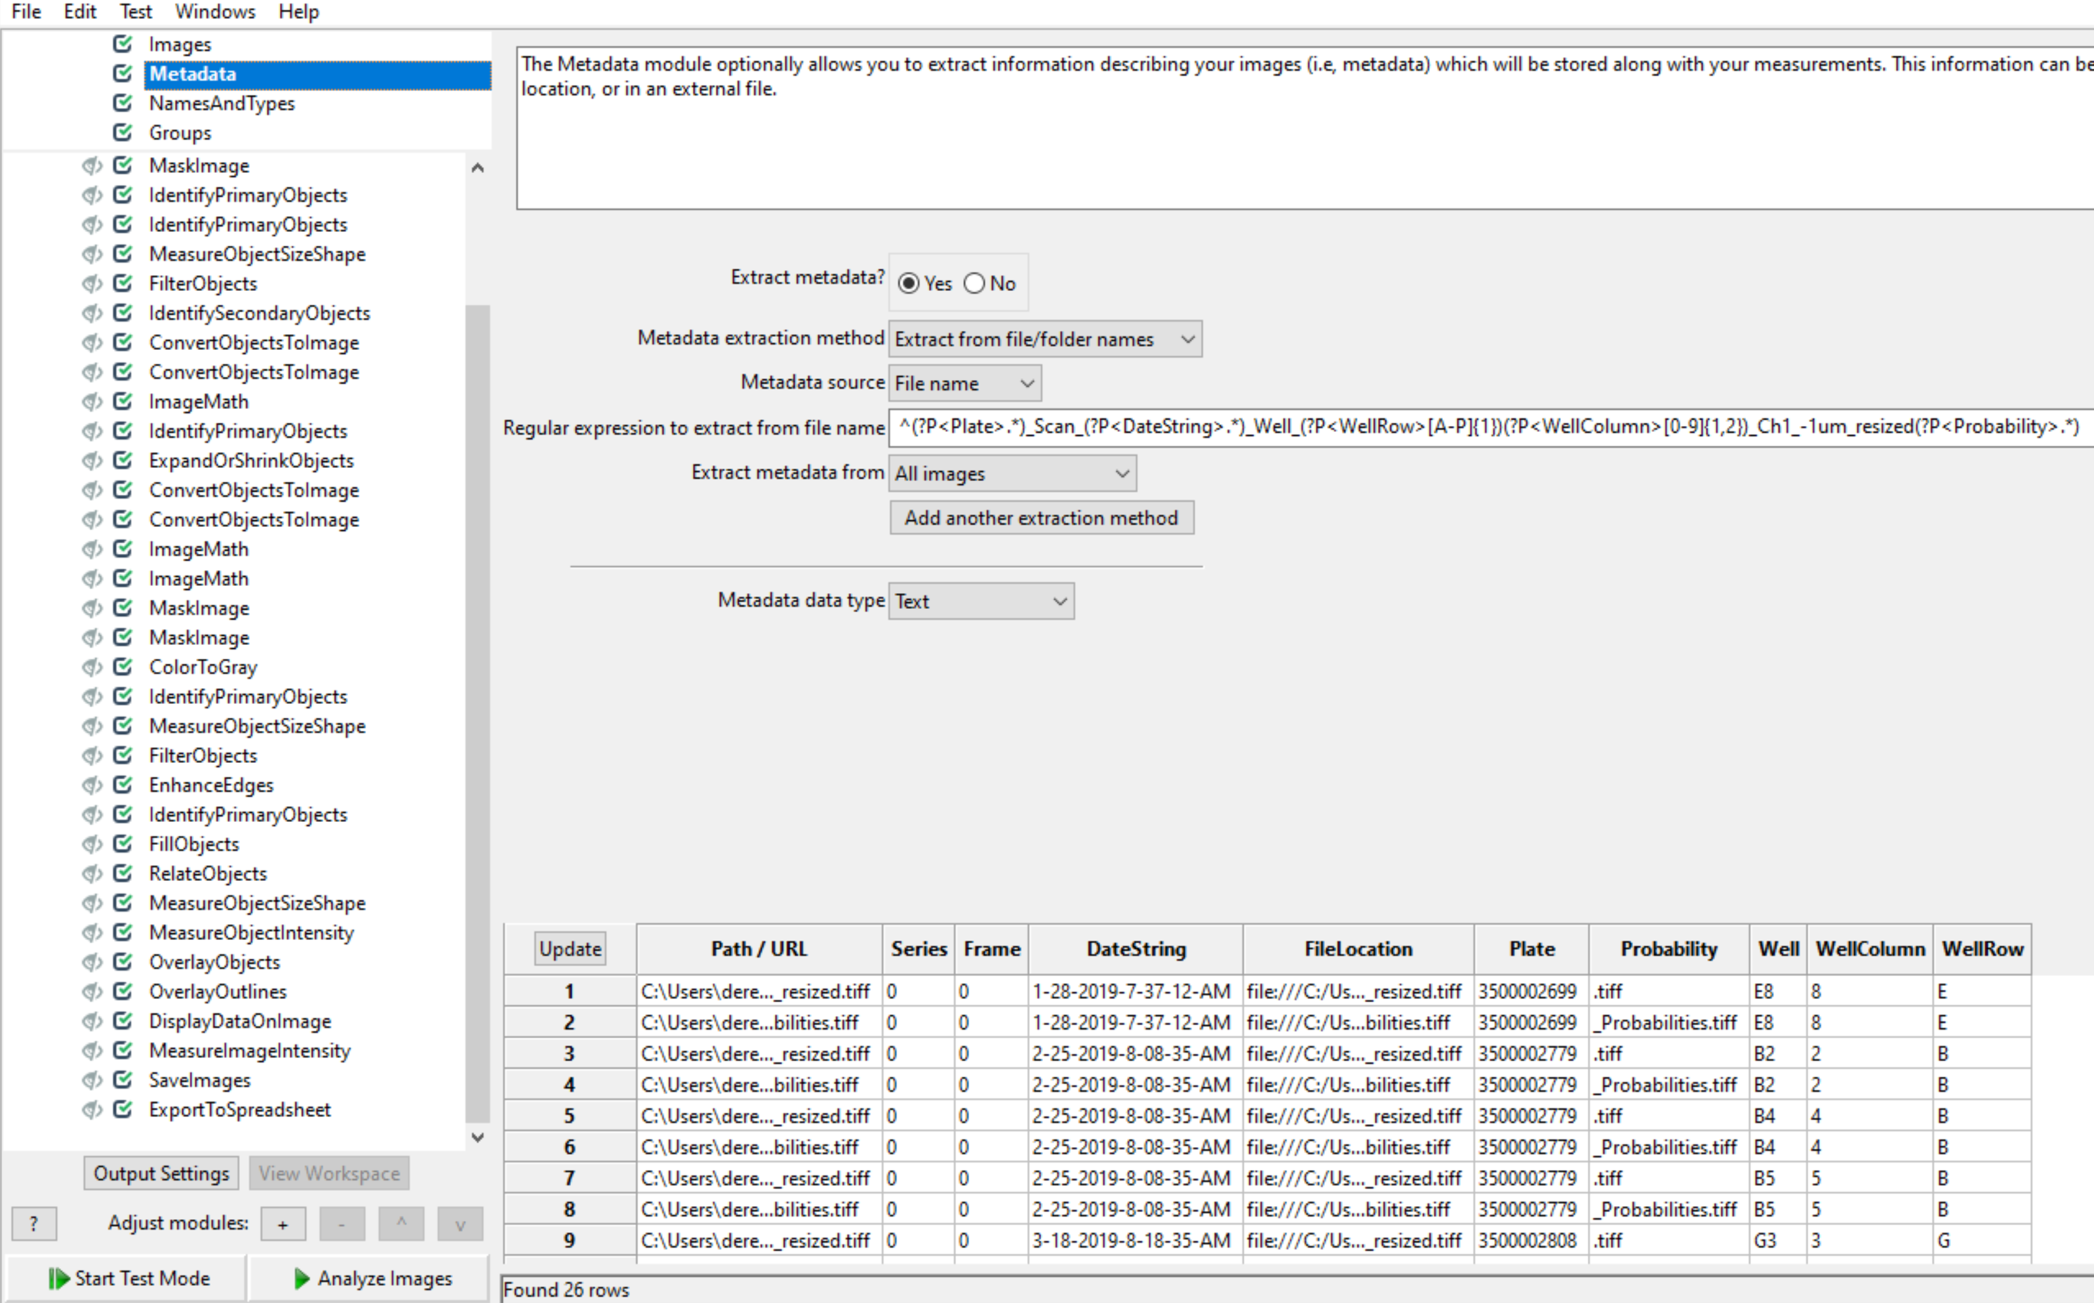

1. Proceed to Names and Types tab. The image matching rules are set to the image names from the celigo brightfield and Ilastik pixel classifier pipeline. Click update to verify that both image column lists are displayed.

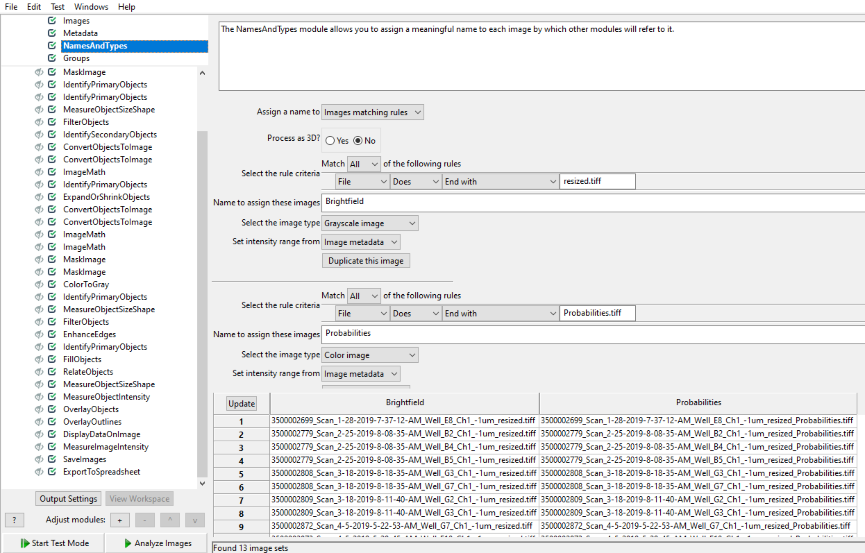

1. Click “Analyze Images” to start processing the image set.

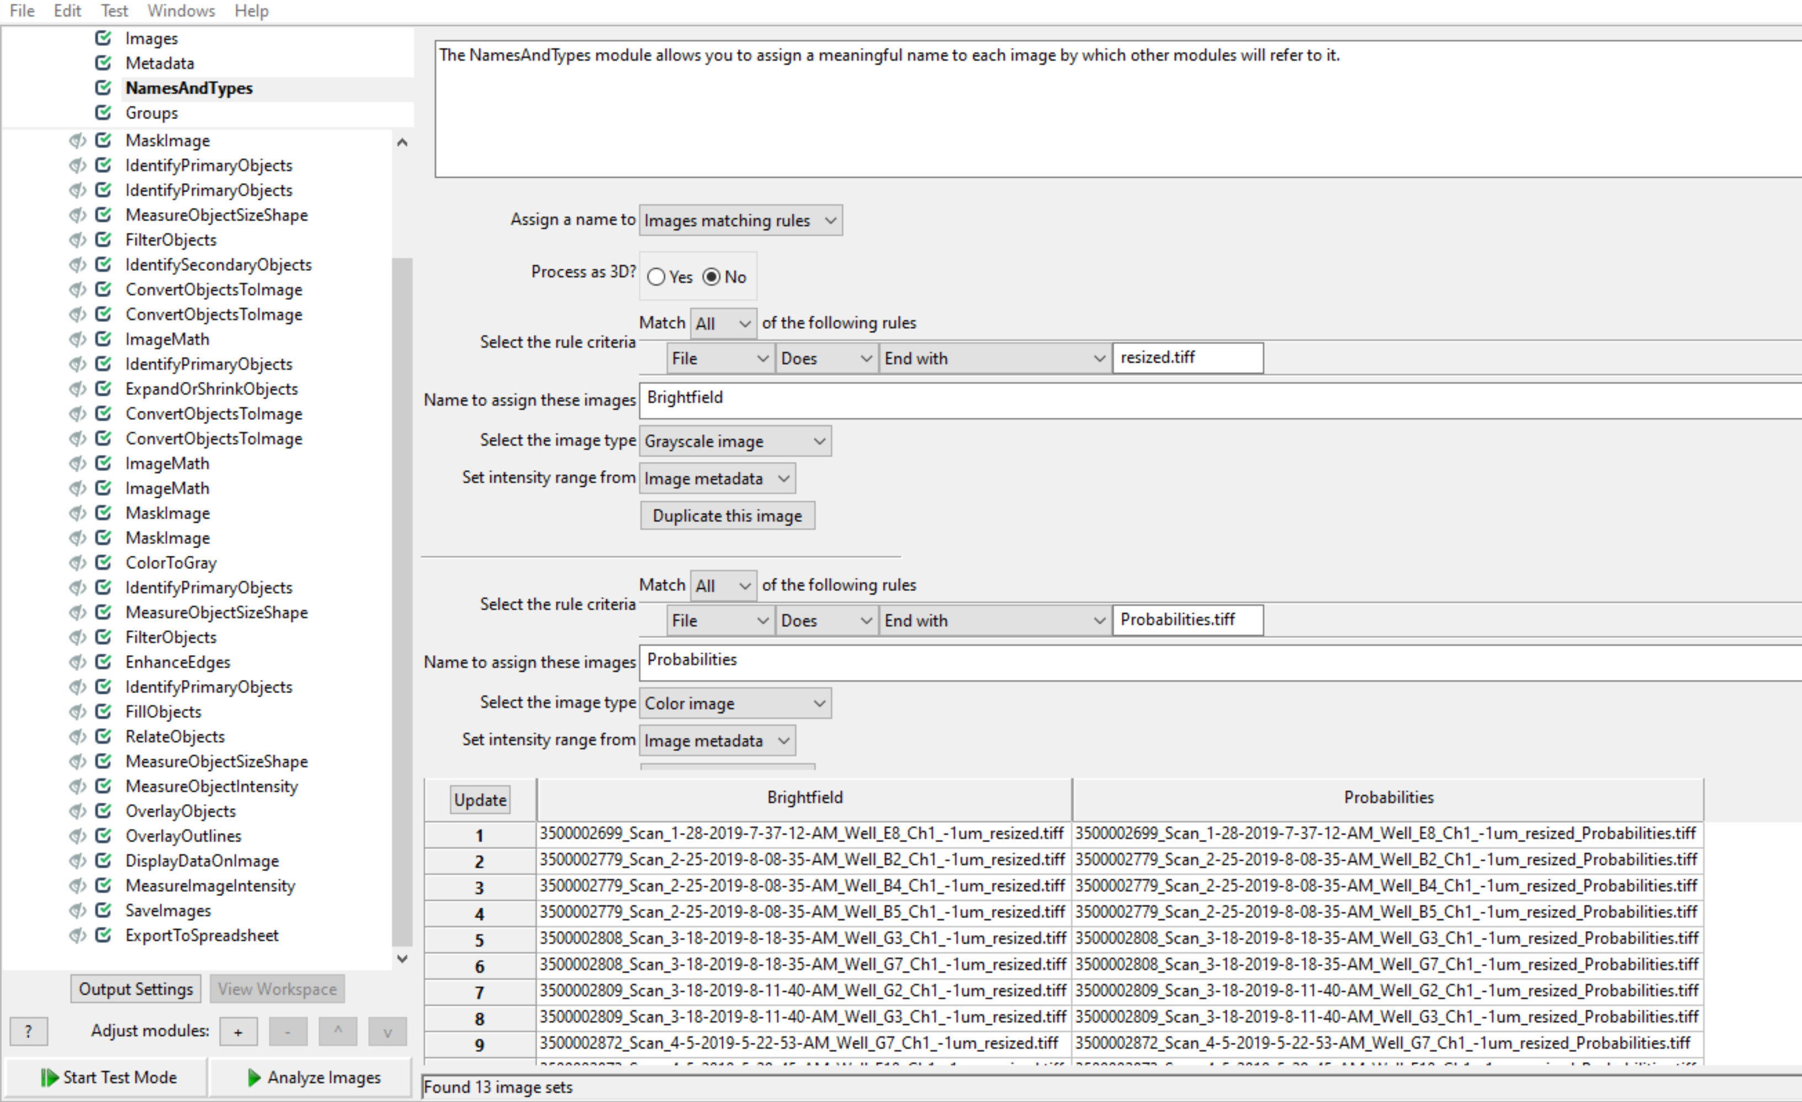

1. The pipeline will take a few minutes to run. Colony measurements results and an overview image with colonies colored and problematic colony areas outlined in red will be saved in the specified output folder.